DEPARTMENT OF COMPUTER SYSTEM ENGINEERING, UET, PESHAWAR.

**Submitted To: Engr. Ammad Khalil**

**Submitted By: Shah Raza (44)**

**Ashiq Ullah (77)**

**Section: B**

**Date: 7/11/2018**

Computer Fundamentals

lab report #4

2018

Table of Contents

**Viewing a Presentation** 2

**Creating a New Presentation** 3

**Entering Text on a Slide** 3

**Formatting** 4

**Adding New Slides** 5

**Applying Slide Transitions** 6

**Printing** 7

**Introduction to Microsoft PowerPoint 2016**

# **Viewing a Presentation**

When you create a Blank Presentation in PowerPoint, the workspace opens in **Normal view**. Normal view is divided into three areas:

1. **Slide Pane** - shows the full layout of a slide
2. **Thumbnails** – shows slide thumbnails
3. **Notes Pane** – used to input text relevant to a specific slide.

Other views include **Slide Sorter view** which shows thumbnails of the entire presentation and **Slide Show view** where you preview your presentation as your audience will see it.

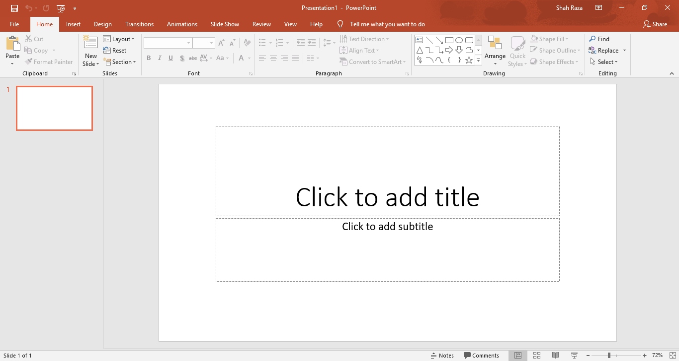

**Slide Show View**

**Slide Shorter View**

**Normal View**

**Slide Pane**

**Thumbnails**

# **Creating a New Presentation**

**To Create a New Presentation:**

1. Click on the **File** tab
2. Click on **New**
3. Select either a Blank Presentation, a featured theme or search for online templates and themes
4. Double-click **Blank Presentation** to create a new presentation

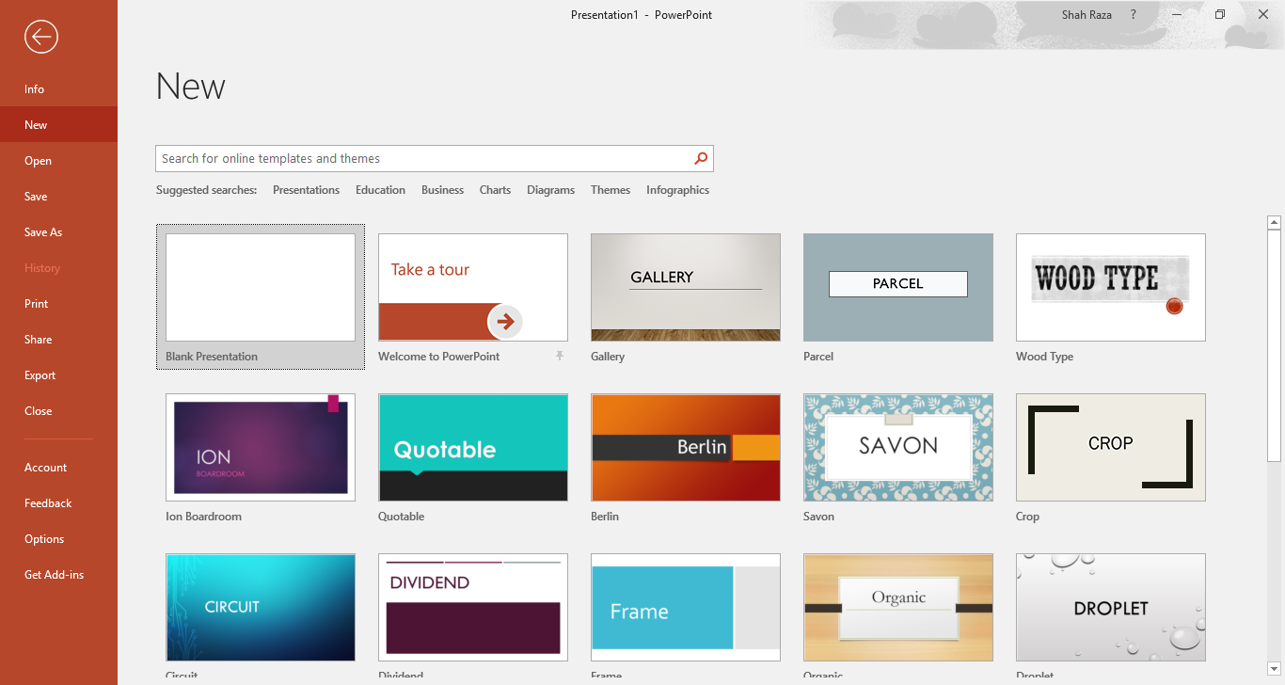

# **Entering Text on a Slide**

When you create a new presentation, the first slide to appear is a **Title slide**. It contains two placeholders: a **title placeholder** and a **subtitle placeholder**. To add text, click within the placeholder and type.



**Placeholders**

# **Formatting**

PowerPoint provides a wide variety of themes that apply a distinctive look to the text, bullets, background colors, and graphics in a presentation. Using a theme is a big time-saver and immediately adds a professional touch to your presentation. You can apply a theme when you create a new presentation and you can change the theme as many times as you want.

**To Apply a Theme:**

1. Click on the Design tab
2. Select one of the themes in the Themes group

To see more themes, click on the **dialog box launcher.**

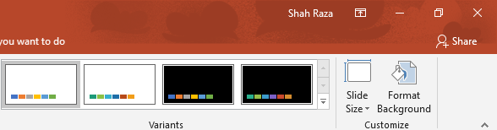

**To Format Text:**

1. Click within the placeholder
2. Select the text to format
3. Click on the **Home** tab
4. Click on the formatting buttons in either the **Font** or **Paragraph** groups
5. You can also use the **Mini Tool Bar** that appears when the text is selected

# **Adding New Slides**

Each slide in PowerPoint has a slide layout. Slide layouts contain formatting, positioning, and placeholders for all of the content that appears on a slide.

PowerPoint includes nine built-in slide layouts:

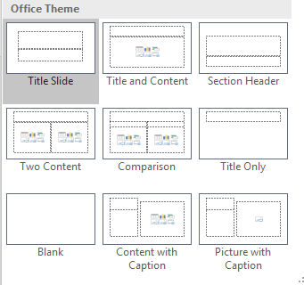

**To Add New Slides:**

1. Click on the **Home** tab
2. Click on **New Slide** in the **Slides** group
3. Choose a slide layout

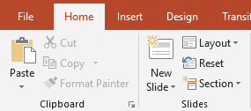

**Content Slides:**

If you choose a slide with content, you will have six types of content to choose from.

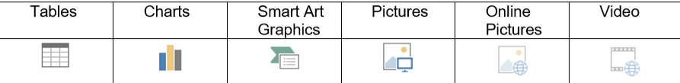

Click on the type of content you want to create and PowerPoint will provide the tools needed to create it.

# **Applying Slide Transitions**

A transition is a special effect that determines how a slide appears as it enters or leaves the screen.

**To Apply Transitions:**

1. Click on the **Transitions** tab
2. Click on the drop-down arrow in the **Transition to This Slide** group to see a listing of all available transitions
3. Click on the transition you want to apply
4. Click on **Apply to All** to apply the transition effect to the entire presentation

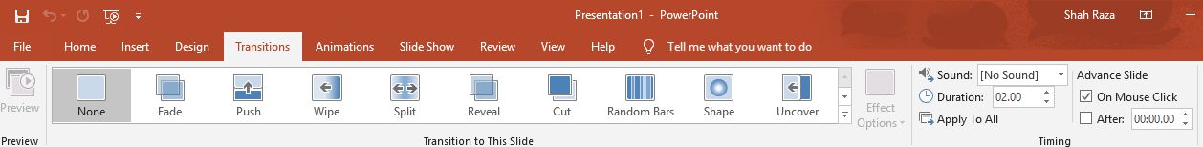

# **Printing**

**To Print:**

1. Click on the **File tab**
2. Click on **Print**

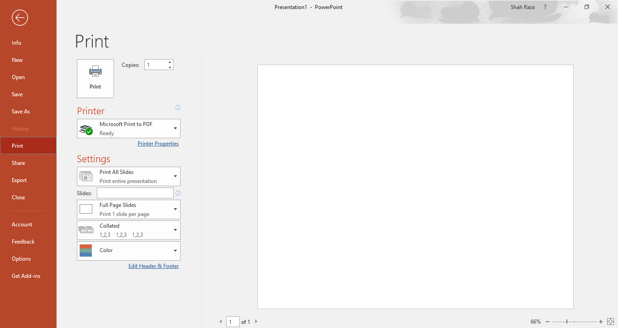

Under **Settings** click on **Print All Slides** and select one of the options to print:

* **Print All Slides** – print entire presentation
* **Print Selection** – only print the selected slides
* **Print Current Slide** – only print the current slide
* **Custom Range** – enter specific slides to print

**Printing Handouts, Notes and Outline**

Click on **Full Page Slides** and choose from the following:

* **Print Layout**
* Full Page Slides
* Notes Pages
* Outline
* **Handouts**
* Choose between 1 – 9 slides per page (horizontal or vertical).